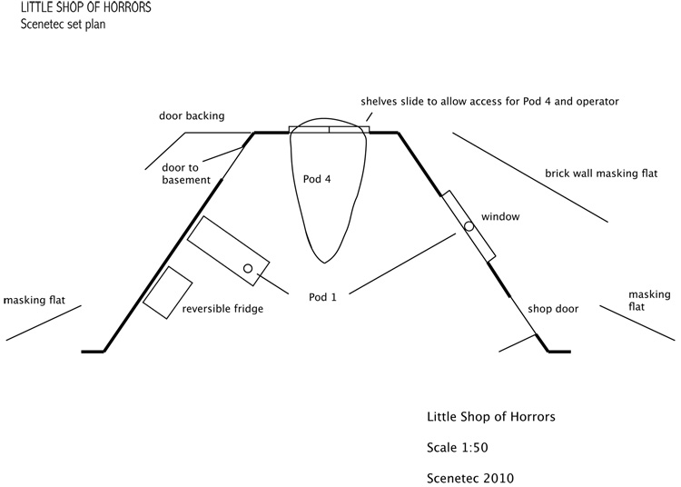

Example of an overhead view of our stage!!!